***Medical/Health Fitness Application***

***Integrated with two features:***

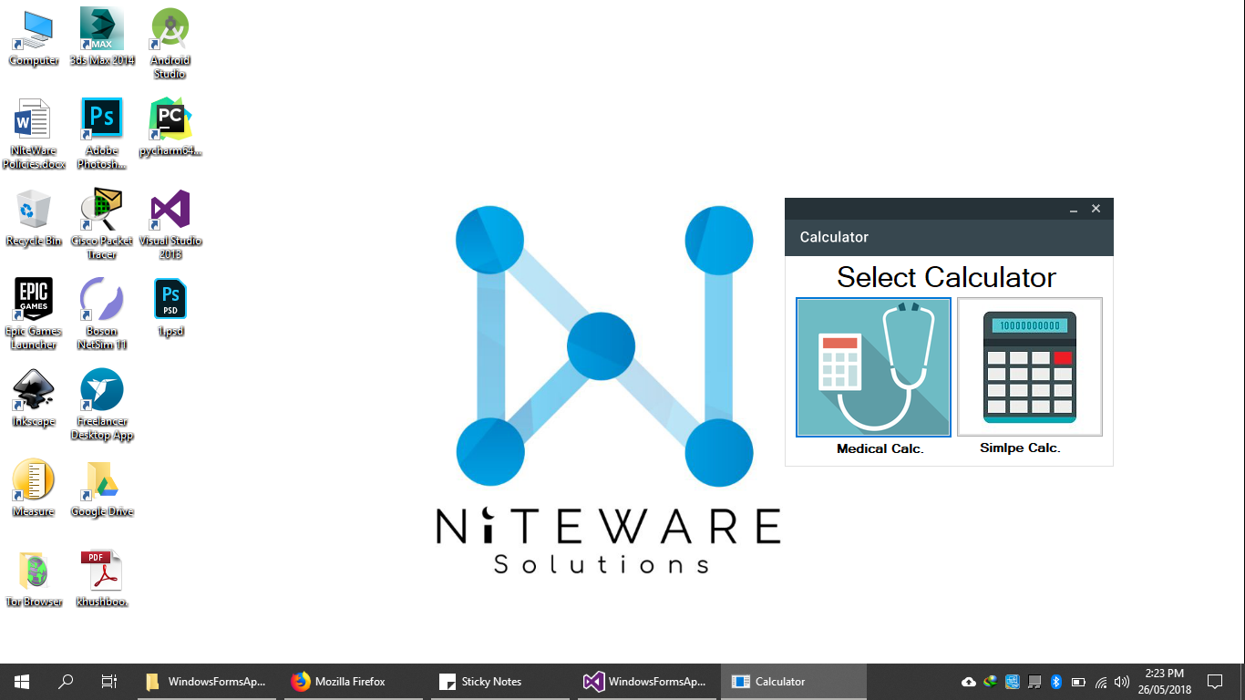

***With Different fitness significance indicators:***

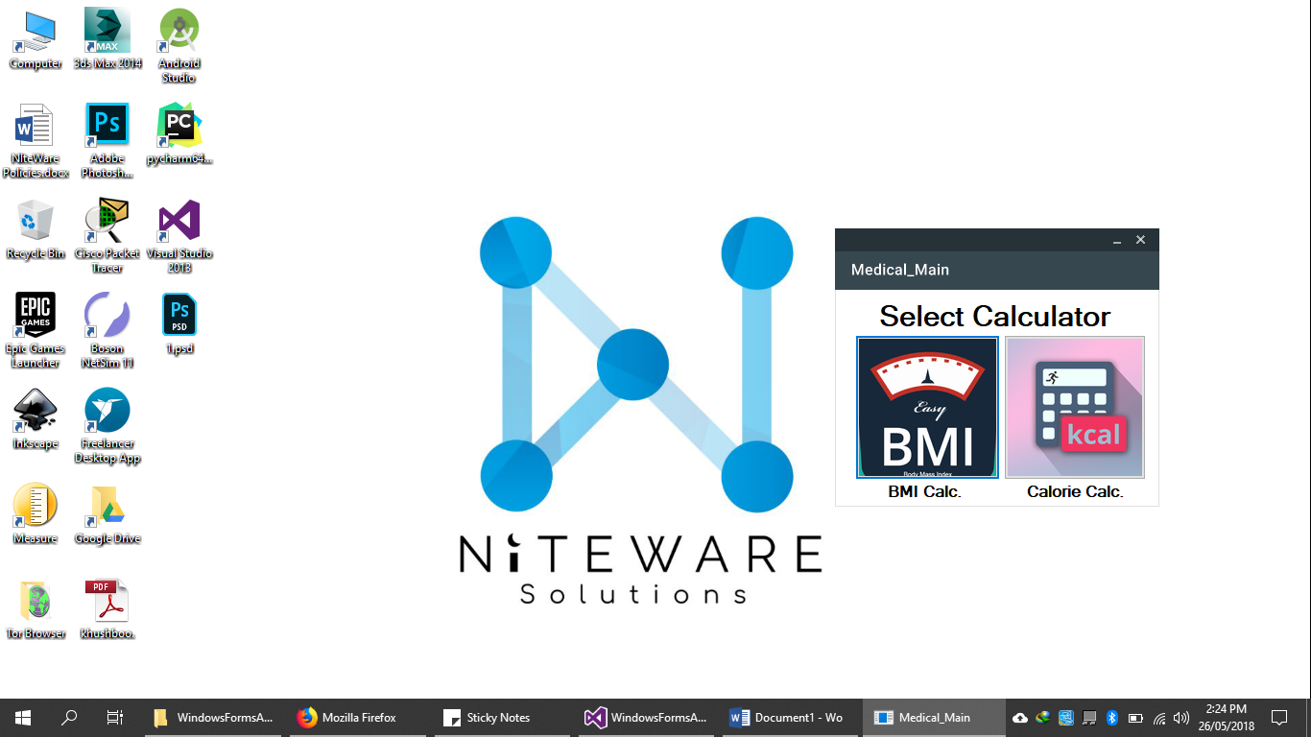

***Fully database integrated:***

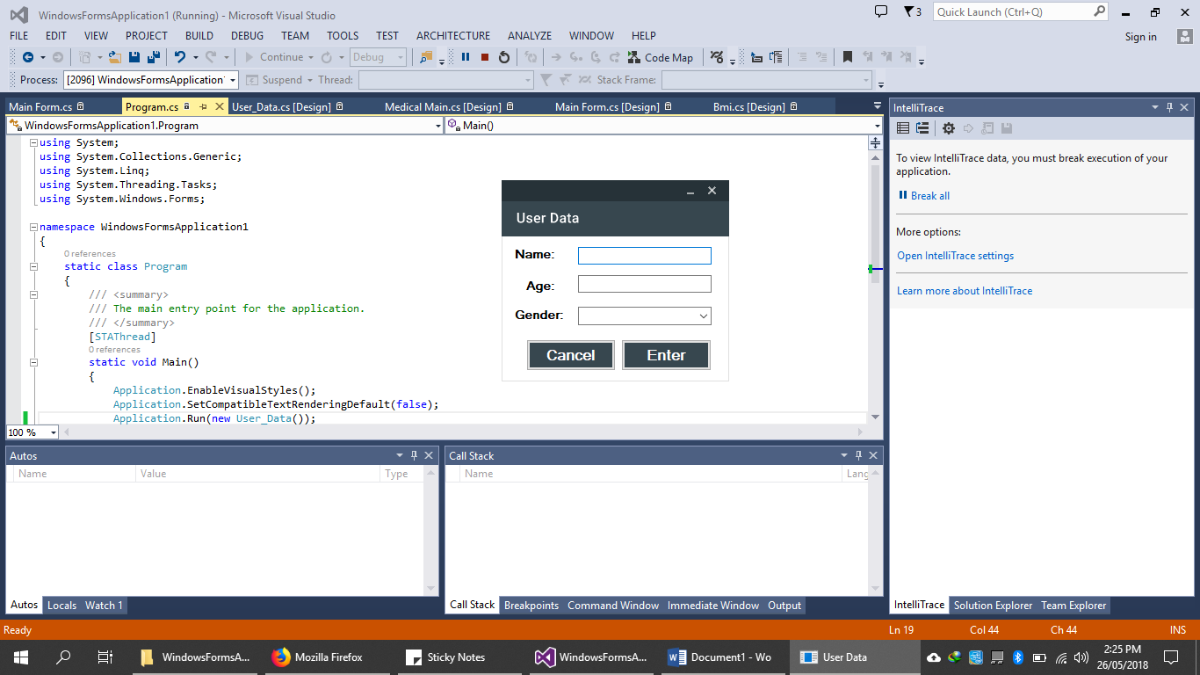

***Efficiently functioning Formal Model Application:***

